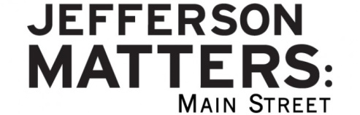
Name of Business/Building:__________________________________________________________
District basic facts needed for National Main Street Accreditation
Is your business considered: _____ retail _____ service _____restaurant/bar
Number of employees: _______Full Time ______ Part Time
Is this building vacant on first floor? _____ yes _____ no
How many residents in this building? __________
What is the taxable value of this property?___________________________
Other optional questions to consider:
Do you have plans to retire, transition, or expand in the next 5 years?___________________________
____________________________________________________________________________________
In what ways can our Main Street program support you in your business?____________________________________________________________________________
Please mark the Main Street programs that you would like more info about:
____ More info on the City’s Phase 2 façade program with a 50/50 match
____ Mini-grants for façade improvements (up to $500)– free design assistance available
____ Mini-grants for signage (50/50 match up to $500)– free design assistance available
____ Design Assistance for façade improvements – free for Main Street buildings
____ New Business Incentive Brochure Program – incentives from existing businesses for new businesses locating to district
____ Involvement on Main Street committees: Design, Promotion, Economic Vitality, Organization, Tower View Team
____ Volunteer opportunities other than committee work:________________________________
____ Free Jefferson, IA app with your business info
____ Java & Juice Friday coffee at my business
____ Business After Hours Educational Sessions: suggestions:_______________________________
____ Attendance at Main Street Iowa conferences

