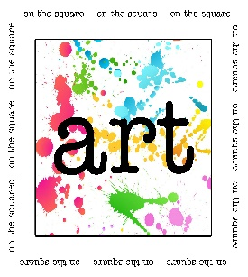 | On the Square
October 12, 2019
10:00 a.m. – 4:00 p.m.
Greene County Courtyard
Jefferson, Iowa
Sponsored by Jefferson Matters: Main Street
110 W. Lincoln Way, PO Box 13 Jefferson, IA 50129
515.386.3585 artonthesquarejefferson@gmail.com
www.jeffersonmatters.org
2019 Application Due September 1, 2019

Standard 10x10 Space - $50 _______
Late fee: $10 postmarked after 9/1/2019
Photos of artwork must be submitted electronically to: artonthesquarejefferson@gmail.com
Please make checks to Jefferson Matters: Main Street

EXHIBITOR’S NAME
BUSINESS NAME
IOWA TAX #
ADDRESS |  |  |  | CITY, STATE, ZIP
ART MEDIA
PHONE |  |  |  | EMAIL
REQUESTS/COMMENTS

I have read the Rules & Important information and agree. I understand my payment for this event is non-refundable. I agree to assume full liability for any injury or loss to me or my property during the event. I expressly release Jefferson Matters: Main Street and its representatives from all liability, or for any loss or injury. Exhibitor agrees to defend, indemnify and hold harmless Jefferson Matters: Main Street and its representatives from and against any and all claims, demands, suits, damages and expenses (including attorney’s fees and costs) or any cause or action whatsoever arising out of Exhibitor’s use of this event.

Signature:________________________________________ Date:__________________________

