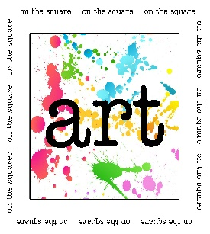 | On the Square
October 12, 2019
10:00 a.m. – 4:00 p.m.
Greene County Courtyard
Jefferson, Iowa
Sponsored by Jefferson Matters: Main Street
110 W. Lincoln Way, PO Box 13 Jefferson, IA 50129
515.386.3585 artonthesquarejefferson@gmail.com
www.jeffersonmatters.org

Musician Agreement
*Please note: All musicians will play at their will. No payment is offered or expected from Jefferson Matters: Main Street or organizers of the art fair.
Name
Contact
Address
City/State/ZIP
Phone
Email

The business/person on the above lines and signed on the bottom of this page have agreed to the following rules and regulations of Jefferson Matters: Main Street.
I/WE agree to be volunteer musicians for the Art on the Square art fair. I/WE agree to keep our area clean of garbage of any type. I/WE will not hold Jefferson Matters: Main Street, or its members and board members, responsible in case of accident and/or damage. I/WE expressly release Jefferson Matters: Main Street and its representatives from all liability, or for any loss or injury. I/WE agree to defend, indemnify and hold harmless Jefferson Matters: Main Street and its representatives from and against any and all claims, demands, suits, damages and expenses (including attorney’s fees and costs) or any cause or action whatsoever arising out of MY/OUR use of this event.

Signature:________________________________________ Date:__________________________

