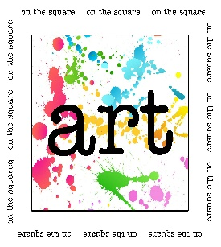 | On the Square
October 12, 2019
10:00 a.m. – 4:00 p.m.
Greene County Courtyard, Jefferson, Iowa
Sponsored by Jefferson Matters: Main Street
110 W. Lincoln Way, PO Box 13 Jefferson, IA 50129
515.386.3585 artonthesquarejefferson@gmail.com www.jeffersonmatters.org
Rules & Important Information

- This is a juried event. Pictures must be submitted and must represent actual items to be sold at the show by all vendors. Pictures must also demonstrate how the items are crafted by exhibitor. Digital photos or web links may be emailed to artonthesquarejefferson@gmail.com

- Sales tax is 7% in Greene County, Iowa.
- All exhibitors must have an Iowa State sales tax number on file in our office. Vendor records are submitted to the Iowa Dept. of Revenue after every show. For a permanent sales tax number, please contact the Iowa Dept. of Revenue and Finance at 515-281-8966.
- The show is held rain or shine. No refunds will be granted. If you must leave early, please contact the organizer with the reason. We ask that packing of materials, teardown or loading of belongings not begin prior to 3:30 p.m. the day of the event.
- All spaces are 10’ x 10’. If your canopy is larger, you will need to rent additional space. All merchandise must be within your assigned space. Spaces will be located on the Greene County Courthouse grounds.
- All items must be hand crafted by the exhibitor. Jurors will visit each booth prior to event start. We reserve the right to dismiss vendors from the show if found to be noncompliant with this rule and no refund will be given.
- Vendor registration takes place at the Welcome Center, 201 E Lincoln Way on the SE corner of the square. Set up may begin by 7:00 a.m. the day of the event. For ease of set up, all exhibitors will be asked to move vehicles after unloading to allow visitors easy access to the fair. Parking is located just off the square.
- Lodging:
- Cobblestone Hotel & Suites located next to Wild Rose Casino - 515-386-3535
- Super 8 on Hwy 30 – 515-386-2464
- Redwood Motel on Hwy 30 – 515-386-3116
- Several Airbnb options
- NO SMOKING within show grounds.

