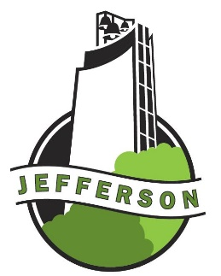
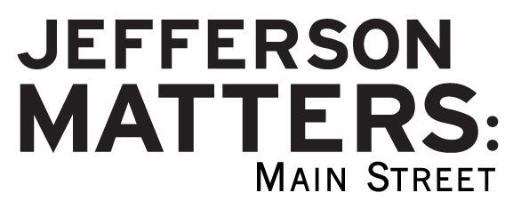

Building Facade

Mini-Grant Application
Up to $500

Purpose of Program:
The purpose of this grant program is to assist building owners in the Main Street District to improve the historic exterior appearance of their buildings. Please review the Design Guidelines approved by the City Council in January, 2016 on the back.

Eligible Applicants:
- Property owners in Jefferson’s Main Street District.
Eligible Projects to be considered for Funding:
- Paint, tuck pointing.
- Replacement of windows and doors.
- Removal of non-conforming elements of a building.
Funding Requirements:
- Maximum request is $500 per building and subject to available funds.
- Once façade project approval is received, grant funds are available on a reimbursement basis only. Please provide receipts.
- “Before” and “after” photos need to be submitted prior to funding reimbursement.
- Will NOT fund labor costs of building owner but volunteers are available for some projects.
- Project must be completed one year from application date approval.

Design Committee approval is needed before your project begins.

Applicant Information

Name: __________________________________________
Contact Person: Mailing Address:
City, State, Zip: _____Daytime Phone Number: _____
Date Submitted: E-mail:
Total Project Cost: $ Amount requested from this grant program: $
Project Address: ____________________________________________________________________
Project Description___________________________________________________________________

__________________________________________________________________________________

The Main Street Program Director along with members of the Design Committee will make recommendations to the Main Street Board at their monthly meeting on projects to fund. Funds are limited to amount budgeted for the year.
Date design is approved by Design Team:______________ JM:MS Board___________________
Date reimbursement is approved by JM:MS Board:______________________
For More Information/Questions:
Contact the Main Street Director at 515-386-3585 or director@jeffersonmatters.org
110 W. Lincoln Way
P.O. Box 13
Jefferson, IA 50129
DOWNTOWN BUILDING DESIGN GUIDELINES
The City of Jefferson advocates/endorses the following guiding principles in rehabilitation, renovation, remodeling and new construction activities within the Jefferson Central Business District. These guidelines are offered to help the property owner and developer make sound investment decisions in the building improvements while enhancing the area’s historic character. Building plans should be reviewed with the city building inspector to ensure substantial compliance with these guidelines.

DO — Recommendations for Historic Renovation:
  - The traditional configuration of the storefront opening should be maintained, with the original storefront line along the sidewalk being maintained or restored.
  - Storefront window display areas should considered an important part of the retail marketing strategy in the downtown area. Large street level display windows should be retained as part of remodeling or new construction.
  - If the storefront has been altered substantially, attempt to bring back original historic proportions throughout the use of design elements, even if they are not a restoration of the original. Avoid altering, concealing or removing historic details when renovating existing older buildings.
  - The original facade, materials and ornamentation, should be maintained and/or restored. Missing facade elements should be replaced with new materials that match the original as closely as possible.
  - Coverings that obliterate the size and shape of upper story windows should be removed.
  - The horizontal alignments or architectural components such as store front windows, kick plates, first story cornices, parapet cornices and window sills should be recreated or restored.
  - Unless damaged beyond repair, architectural designs on the parapet should be maintained
  - The mass, volume and height of new buildings should be compatible with existing buildings in the immediate area.
  - Selected building materials should complement and be compatible with existing buildings in the immediate area.
  - Exterior remodeling should be designed to consider the entire building facade. The ground floor exterior should be designed to harmonize with the upper stories.
  - Existing buildings and structures should be recognized as products of their own time. Alterations which have no historical basis are discouraged.
DO — Color choices: As you choose colors to beautify your building, please consider ones that would also complement surrounding buildings and coordinate with the overall attempt to restore historical beauty to our Business District. The Main Street office is available to offer assistance with color choices.
Don’t — For Rehabilitation and Remodeling, the following are prohibited:
  - Adding elements that are not original to the building, such as aluminum, vinyl, or fiberglass siding or roofing materials corrugated or beveled metal siding, highly tinted or mirrored glass, or corrugated fiberglass.
  - Any material that attempts to mimic conventional building materials. For example: fiberglass panels that are molded to look like brick, or imitation metal rock work.
  - Concrete block or brick larger than 4 inches in height, 12 inches in length
  - New window openings or eliminating original window openings.
  - Changing the roof design or style where visible from the ground
  - Roof heating/cooling units visible from the street level
  - Vinyl and metal screen/storm doors
  - Astro turf, indoor-outdoor carpeting
  - Removing or destroying original transom windows
  - Removing, concealing or covering a cornice
  - Removing, concealing or covering a parapet
Additional information and guidance on historical restoration is available from the Jefferson Matters: Main Street office.

