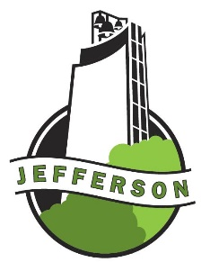
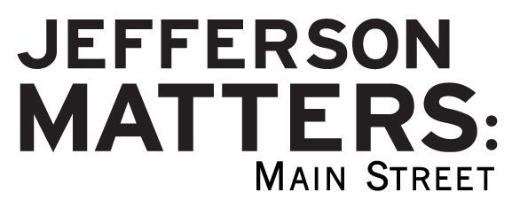

Storefront Signage

Mini-Grant Application
Matching up to $500

Purpose:
This grant program is to assist building & business owners in the Main Street District financially with new signage.
Eligible Applicants:
- Property & business owners in Jefferson’s Main Street District.
Eligible Projects to be considered for Funding:
- New wall mount and projecting signage on exterior of business.
Terms & Conditions:
- This is a 50% matching grant for materials/installation of signage up to $500.00.
- Once signage project approval is received from Jefferson Matters: Main Street, grant funds are available on a reimbursement basis only. Receipts are required.
- “Before” and “after” photos need to be submitted prior to funding reimbursement.
- Project must be completed six months from application date approval.
- Grant funds to be awarded as funding is available.
Application Procedure:
- Obtain a design for your signage by meeting with Main Street Iowa design consultants or a signage professional. A simple design assistance form is needed for MSI’s free service.
- Obtain a color drawing of your proposed signage from either Main Street Iowa or a signage professional.
- Attach drawings to this completed Signage Mini-Grant application.
Main Street’s Design Team approval is needed before funding is considered.
Applicant Information

Building/Business Name: Click or tap here to enter text.
Contact Person:Click or tap here to enter text. Mailing Address: Click or tap here to enter text.
City, State, Zip: Click or tap here to enter text.Daytime Phone Number:Click or tap here to enter text.
Date Submitted: Click or tap here to enter text.E-mail: Click or tap here to enter text.
Total Project Cost: $Click or tap here to enter text.Amount requested from this grant program: $Click or tap here to enter text.
Project Address: Click or tap here to enter text.
Project DescriptionClick or tap here to enter text.

Signature:Click or tap here to enter text. Click or tap here to enter text.
Business Owner Building owner if different

The Main Street Director along with members of the Design Committee will make recommendations to the Main Street Board at their monthly meeting on projects to fund. Funds are limited to amount budgeted for the year.
Date design is approved by Design Team:______________ JM:MS Board___________________
Date reimbursement is approved by JM:MS Board:______________________
Your application and drawings will be returned to you after approval.
For More Information/Questions:
Contact the Main Street Director at 515-386-3585 or director@jeffersonmatters.org
110 W Lincoln Way, P.O. Box 13, Jefferson, IA 50129
The completion of our building façade projects has given our Jefferson downtown area a wonderful historic look. The addition of new signage is important in making our downtown vibrant and welcoming. How can we assist you?

Signage Guidelines from Main Street Iowa:
It is important to convey your personal brand or business image in a manner that is simple and unique. As you decide how to express the identification and personality of your business, there are several considerations for your signage. The Main Street program offers materials, resources and free design assistance through Main Street Iowa if requested. Please review materials included on these design elements.

- Shape and proportion
- Location
- Size
- Colors
- Style of Lettering
- Lighting

City of Jefferson Zoning Requirements:
- Constructed of durable, weather resistant material
- Professionally crafted
- Mounted at least 12 feet above sidewalk as measured from the bottom edge of the sign if a projecting sign
- Mounted at least 8 feet above sidewalk as measured from bottom edge of the sign if a wall mount/cabinet sign
- Mounted at least two feet back from the curb as measured from the outside edge of the sign if projecting sign
- Projecting signs may project to a maximum distance of 5 feet from a building with a maximum thickness of 2 feet
- Projecting signs may not have any flashing, blinking, rotating, or moving part, except to denote public service information similar to a "time/temperature" portion, which must be at least 12 feet above grade.
- All signs must comply with City codes and zoning requirements. Contact City Hall at 385-3111 or at 220 N Chestnut.
- A building permit is required prior to construction and is available at City Hall.

